**Using the Clearing House Client Portal**

Clients can now request an update on the current stage of their Clearing House referral, using the client portal page - [https://clearinghouse--dev2022.sandbox.my.site.com/CHClientPortal](https://clearinghouse--dev2022.sandbox.my.salesforce.com/servlet/networks/switch?networkId=0DB3O0000000N0T)

From the Client Portal, they will need to navigate the ‘Check the status of your Clearing House Referral’ page, which they can do either using the tab at the top of the page or the link on the right hand side.





Once they click onto that page, they will see a box where they need to enter their Referral number to receive an email with the details of the current status of their referral.

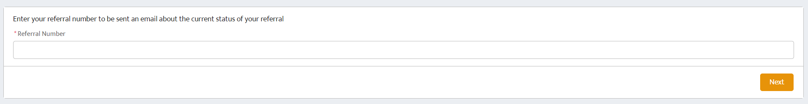

As it explains on the page, they will only receive this if their referral has been accepted onto the waiting list, and if their client record on the system has an email address associated with it. If they don’t receive an email then they are prompted to contact their referral worker to check both of these things.

If they do have an email address on the system, they should have received their referral number in an email once their referral was accepted onto the waiting list. This email will also contain a link to the client portal and details of how they can check the status.

**What if a client doesn’t have access to emails but would like an update?**

If a client doesn’t have an email address, or they do not use email frequently, they can request a status update from their referral worker who can print off the details for them instead.

To do this there are some buttons on the referral page and this will generate a document that can be printed off, which contains the same information as the email that they would receive.

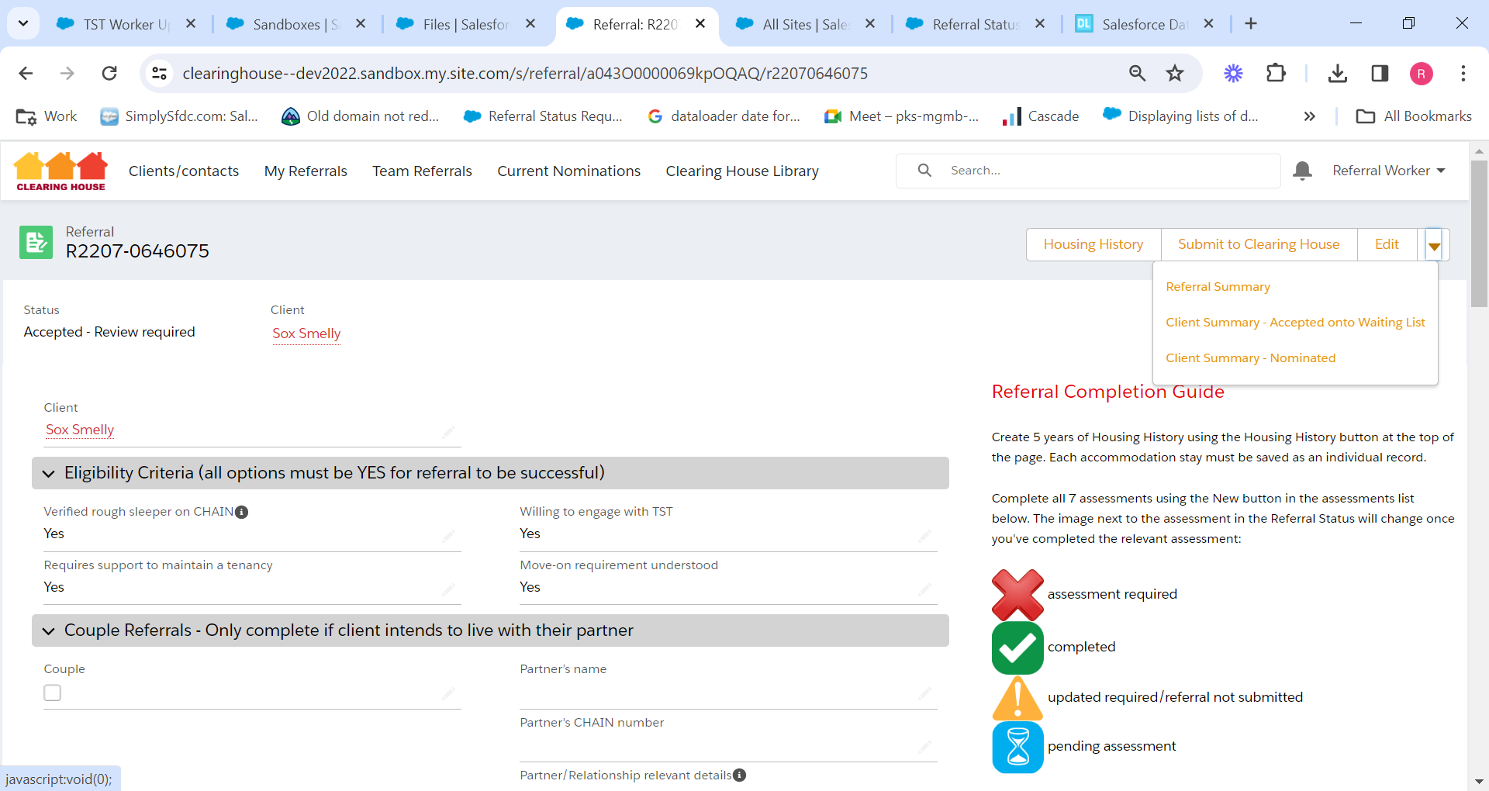

The Client Summary buttons should only be used if the referral is at Accepted onto Waiting List or Nominated stages, so you will need to check the stage before printing off the relevant summary. If the referral is at any other stage then the summary refers the client back to the referral worker anyway for further information so having that printed out would be of little use.

Once a client has been housed, they will no longer be able to request a copy of their referral status using their referral number.