**Landlord user guide**

**Logging in to Clearing House**

Check that you are using the correct user name, the format is first name.surname@clearinghouse.org. For example, jane.doe@clearinghouse.org

Password resets can be requested from the CH login page at <https://clearinghouse.force.com/login>

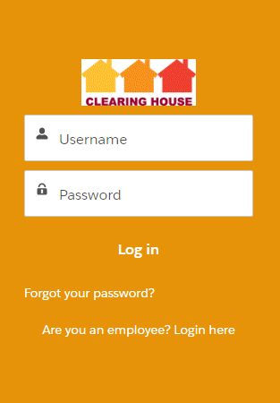

Accounts that have been inactive for 6 months or more are automatically locked. To reactivate a locked account contact the Clearing House Helpdesk by telephone 020 38566008 or email [ch@mungos.org](mailto:ch@mungos.org)

**Finding the Clearing House Library**

When you log in, you will see a tab called More. Click this and you’ll see Clearing House Library as one of the options. When you click on it the library when open in a new tab.

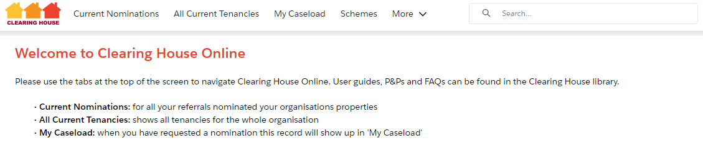

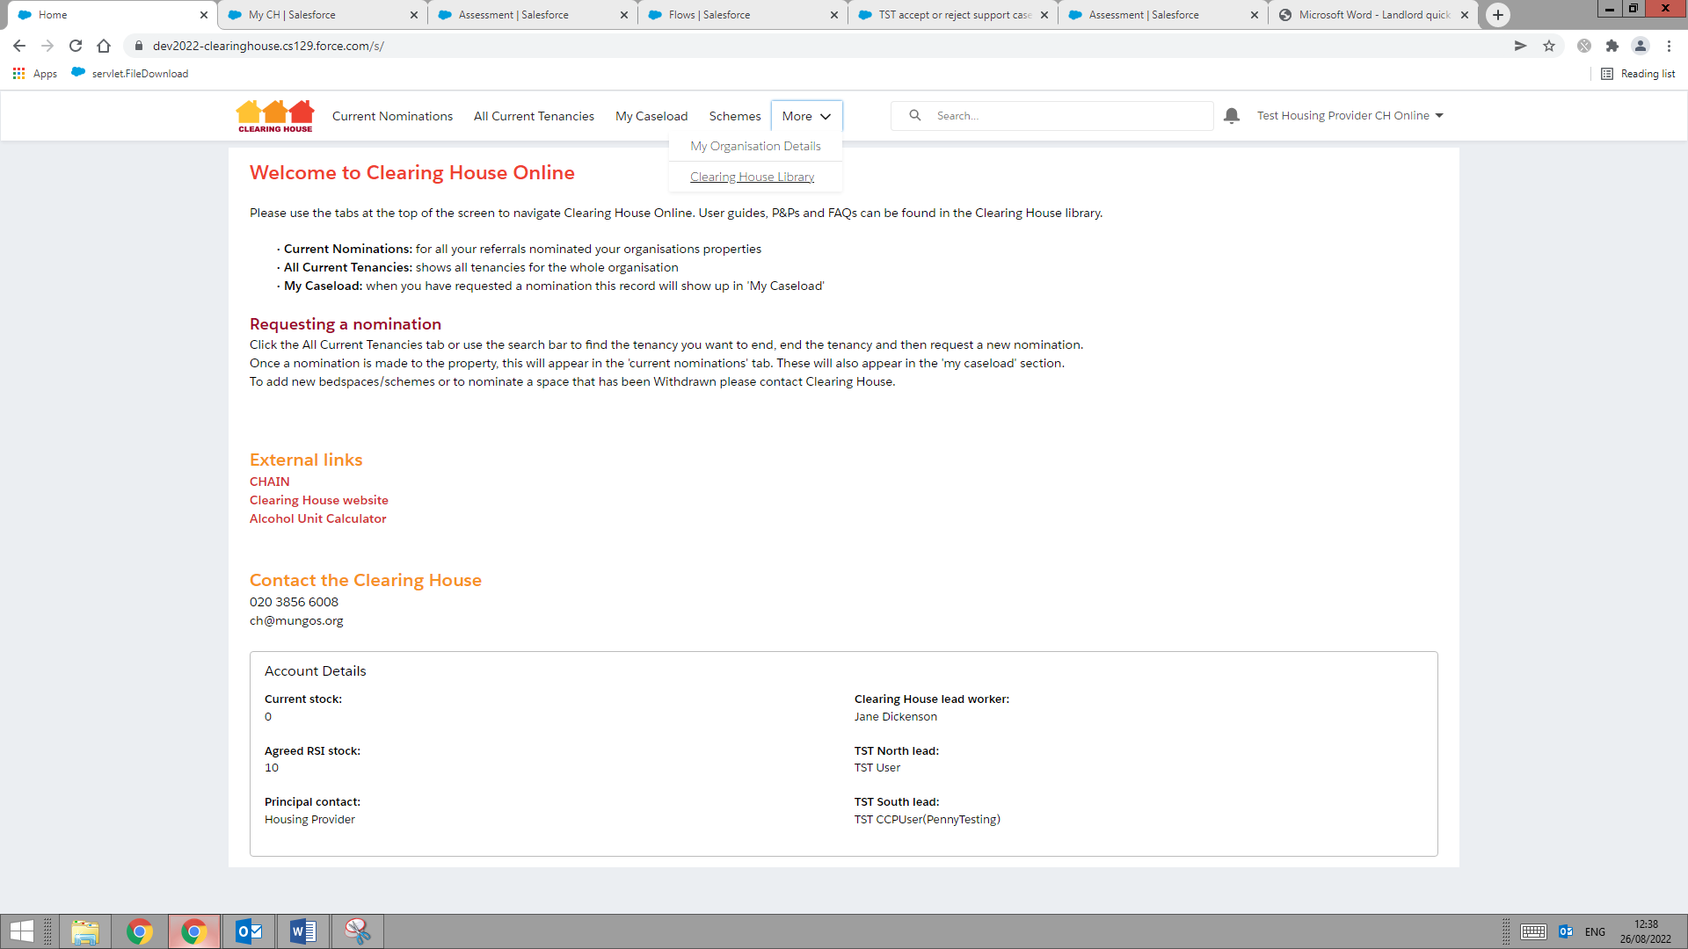

You can also find the Clearing House Library at <https://www.mungos.org/our-services/clearing-house/#user_guides>

If you can’t find something you are looking for, or need to speak with a member of the team, please contact us using the Contact Information on the Home Page.

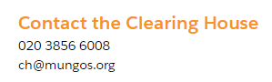

**Returning to the Home Page**

Simply click on the Clearing House logo:

**Making edits to forms**

Any time you would like to edit a form, simply hover over the right hand side of the information you wish to change, where you can see a faint grey icon:



Once you hover over it, it will turn a darker shade:



You can then click to add/edit the information:

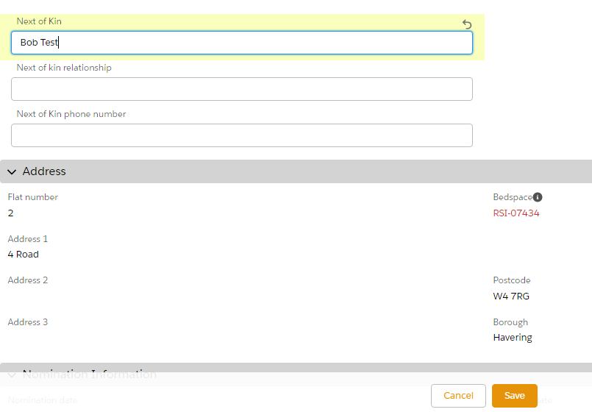

And click Save to finish:



Alternatively, you can simply double click on the information you wish to edit, and you’ll then see the edit box appear:



If you’re searching for someone’s name to select them on a page (e.g. assigning yourself as the TST worker), please **do not** click on the New Contact option:

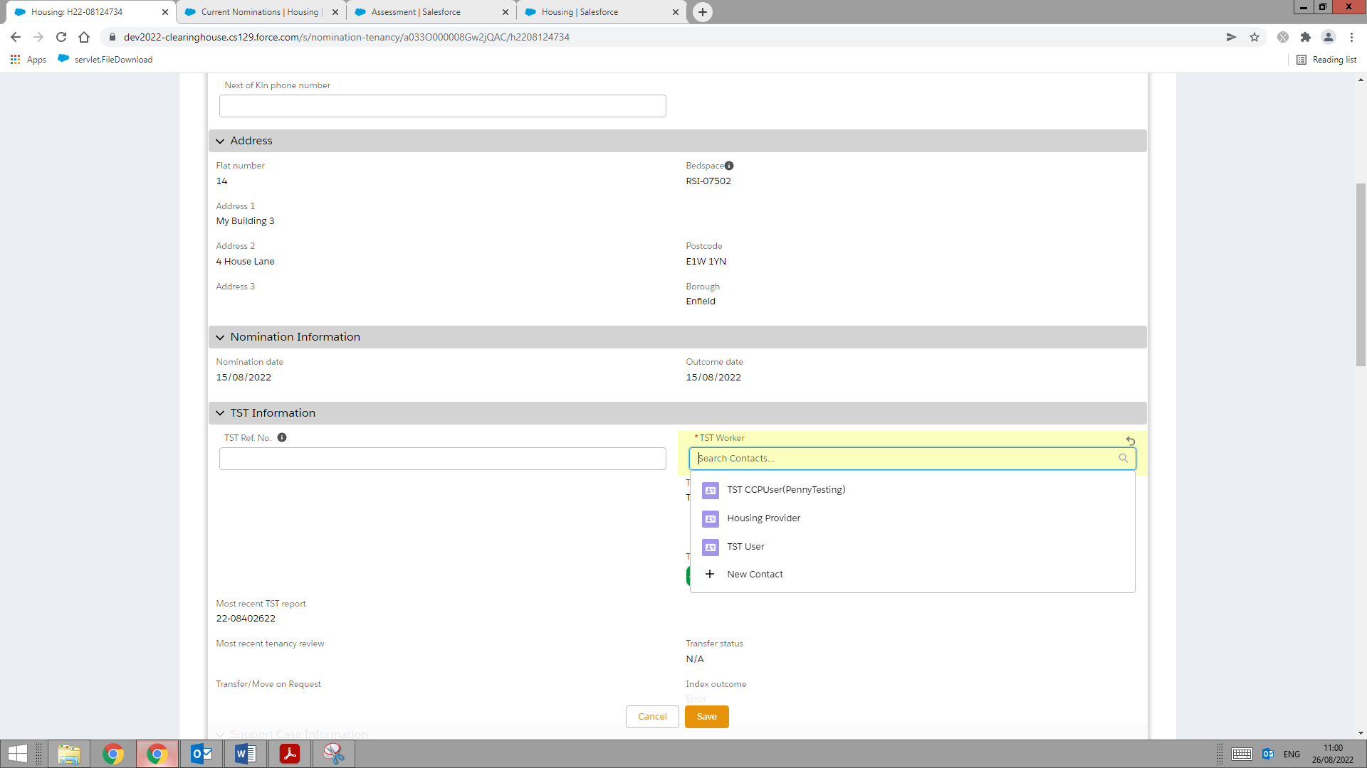

**DO NOT USE THIS**

A red star means this field is mandatory and you won’t be able to save without having completed it:

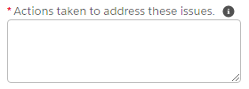

If you see an icon like this on the right - 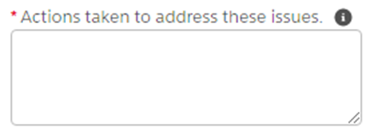 -it will show help text when you hover on it:

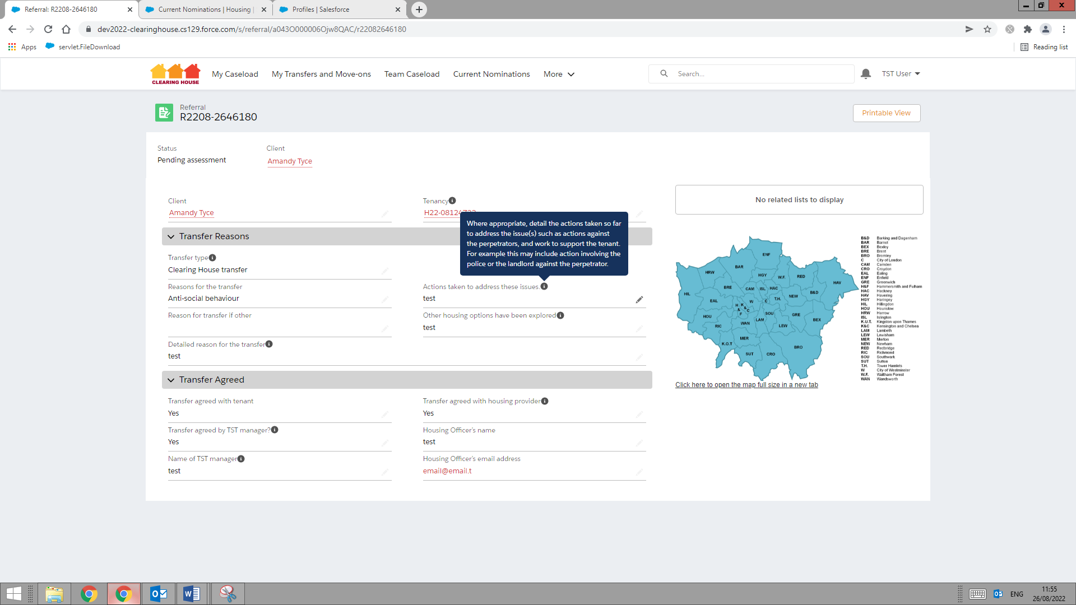

If you’re using Chrome as your internet browser and are typing into a text box that you would like to make bigger, you can use the icon in the bottom right to drag the text box to be larger- just click then drag:



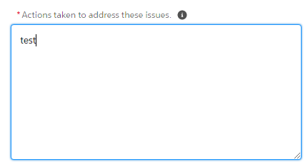

When you need to enter a date, you can either type it in using dd/mm/yyyy format (e.g. 02/10/2022) or use the date picker that appears to select the appropriate date:

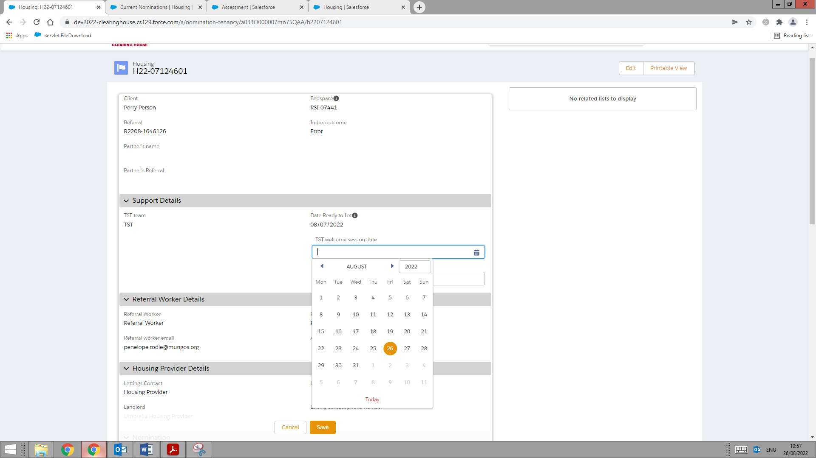

**Finding a tab**

If you ever can’t find a tab referenced in this, you may find it in a tab called More:

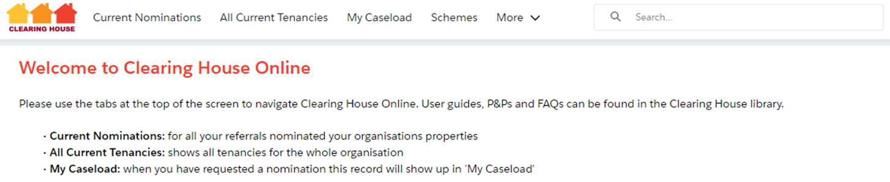

**Ending a tenancy from the bedspace page**

There are two ways you can end a tenancy- do whichever one you feel more comfortable with, just remember either way to request a nomination afterwards.

To end a tenancy from the bedspace first find the property: enter the first line of the address, or just part of it - e.g. Caxton or Caxton Road, into in the Search box at the top of the page and hit return. Do not include the flat/house number as this will not work:



You will then see this screen – click on the scheme name:

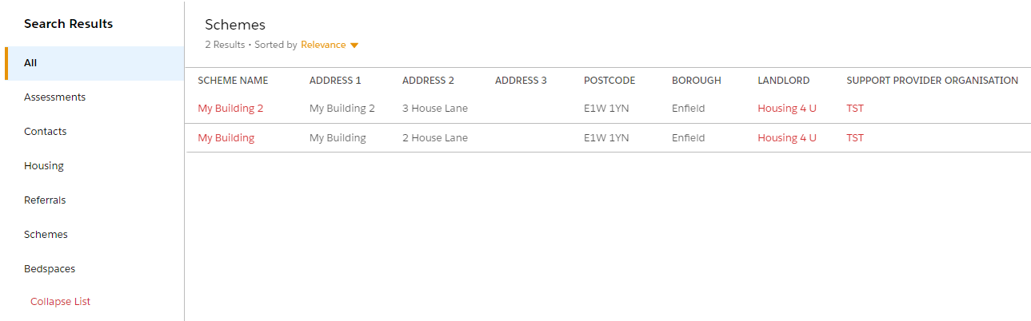

You will be taken to the scheme’s page:

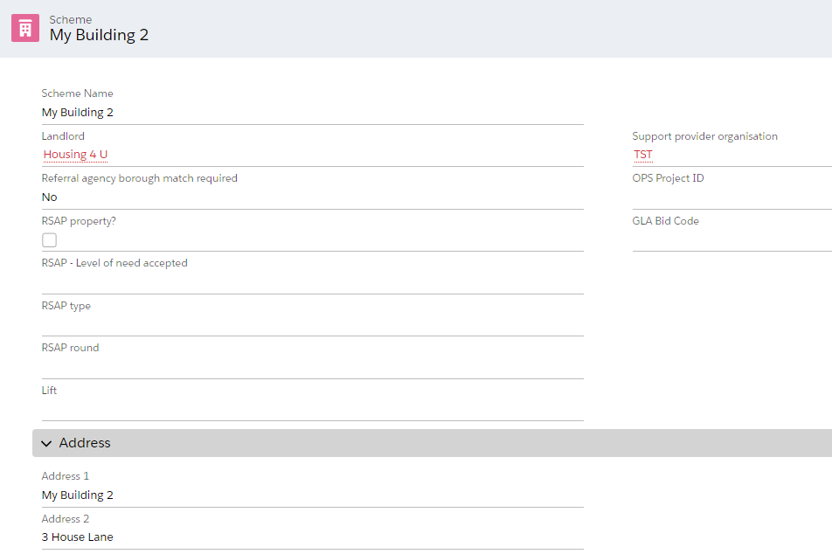

Scroll down to the bedspaces section and you’ll see the first 6 bedspaces, with an option to click on ‘View All’ to see the rest:

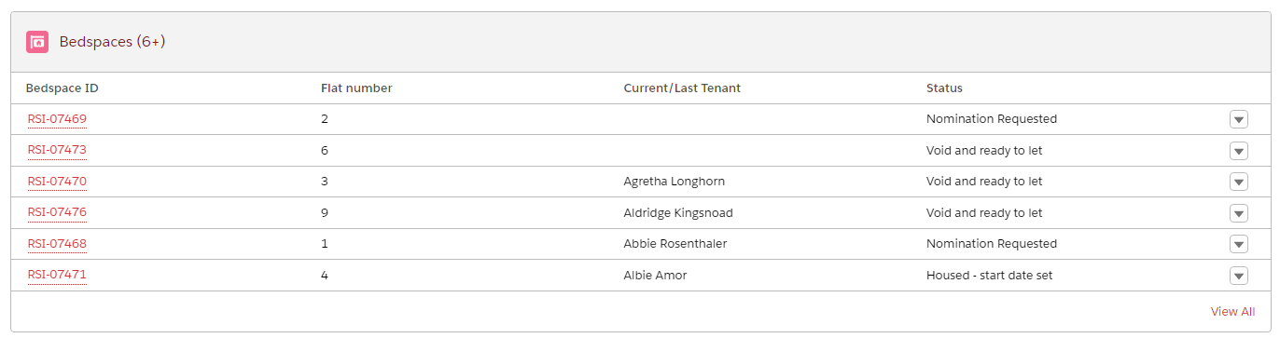

Click on the bedspace relating to the tenant whose tenancy you want to end:

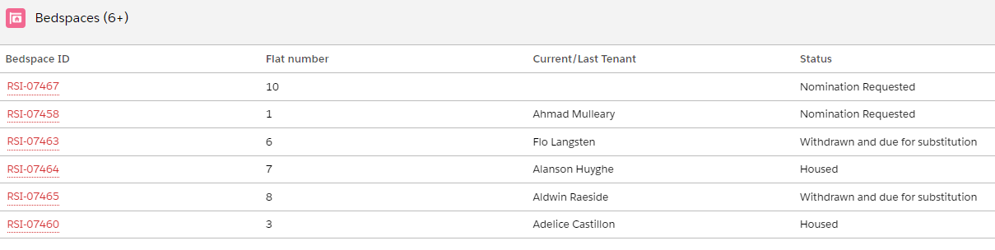

Click on the ‘End Tenancy’ button at the top of the screen and a box will appear with a message reminding you to request a nomination afterwards – just click Next.

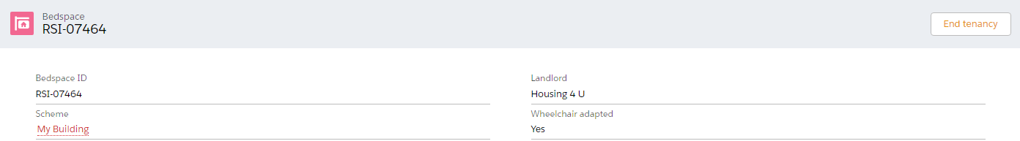

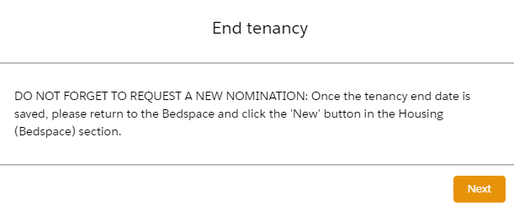

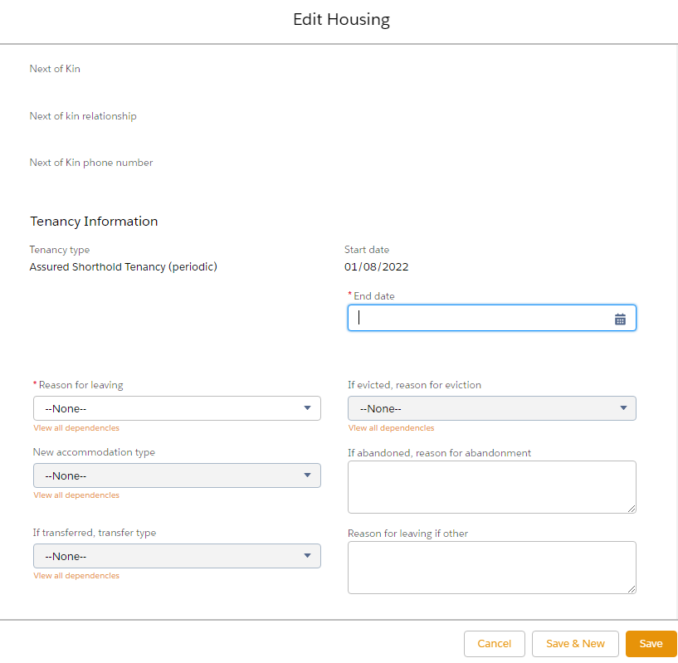

Fill out all the information and click Save. You will find that you can’t edit all the information (e.g. the Next of Kin section on the top left of this example) , so just focus on the areas where you can edit, as that is what needs to be completed at this stage.

Once you’ve done this you will be on the tenancy screen and need to return to the bedspace so that you can request a new nomination. Scroll down to the Tenancy Information section and click back into the Bedspace:

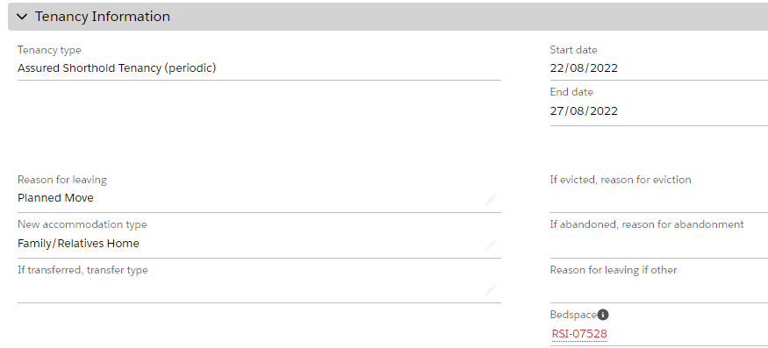

**Ending a tenancy from the tenancy page**

Go to the All Current Tenancies tab and click into the tenancy from the red link (HXXXX..):

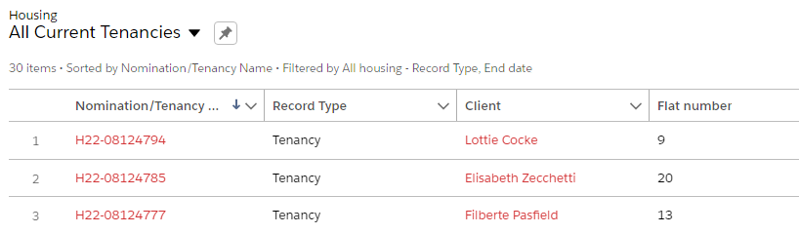

Click the End tenancy button:

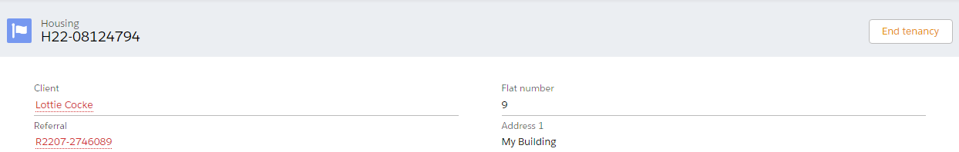

A box will appear with a message reminding you to request a nomination afterwards – just click Next.

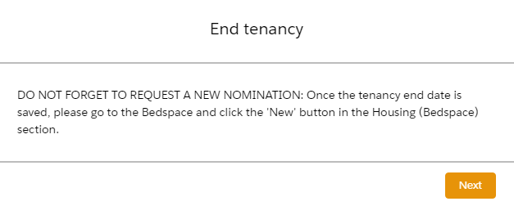



Fill out all the information and click Save. You will find that you can’t edit all the information (e.g. the Next of Kin section on the top left of this example) , so just focus on the areas where you can edit, as that is what needs to be completed at this stage.

Once you’ve done this, scroll down to the Tenancy Information section and click into the Bedspace, so that you can request a new nomination:



**Requesting a nomination**

Having ended the tenancy using either of the options above, scroll down until you see the Housing (Bedspace) section and click ‘New’:



Fill out and the information and click ‘Save’:

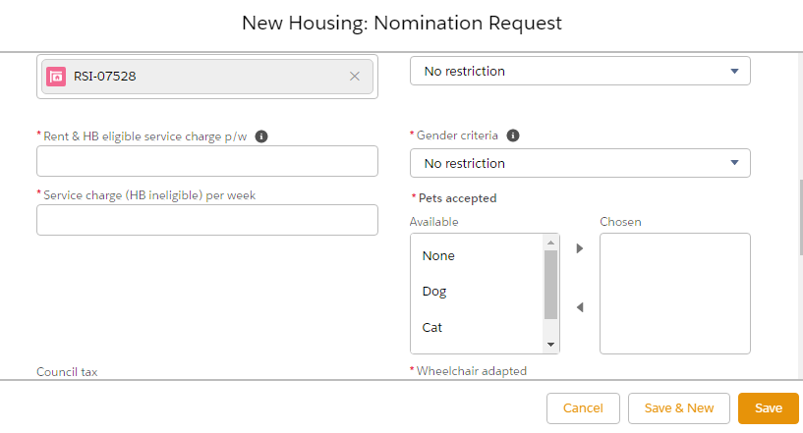

You will see this message appear on the bed space: 

**Viewing current nominations**

When you receive a new nomination and are ready to look at the client’s referral, go to the Current Nominations tab:

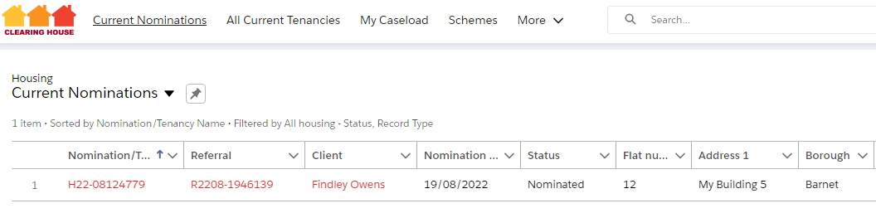

To view the referral, click the red link starting with R in the Referral column.

The view the client’s support needs, risk assessment, etc, click into the assessment where you see a link:

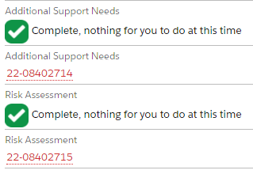

**Submitting nomination outcomes**

From the current nominations tab, click into the tenancy record using the red link that starts with HXXXX:



Then click the Submit Nomination Outcome on the top right:

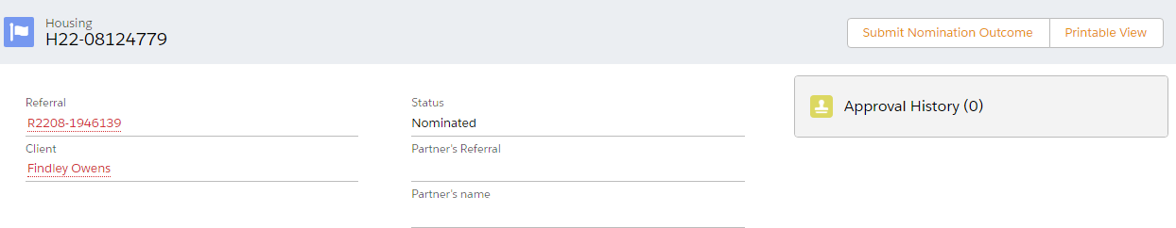

Scroll through and fill out all the information, then click ‘Save’:

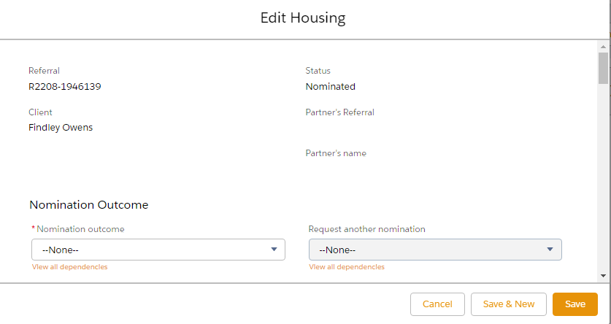

Once you’ve clicked ‘Save’ you’ll see in Approval History on the right side of the page, that Clearing House have received the nomination outcome:

